Flutter lab 4+5

**Practice Questions**

Question 1: Part (1-5)

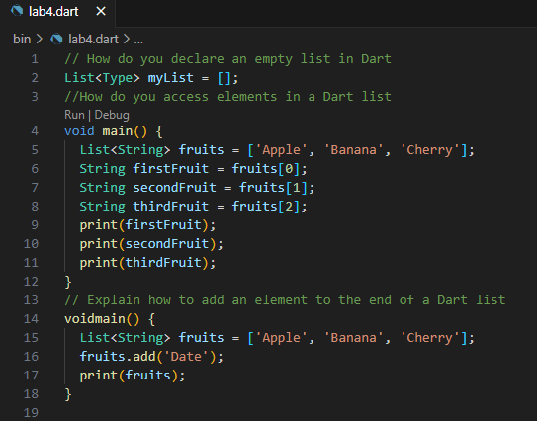

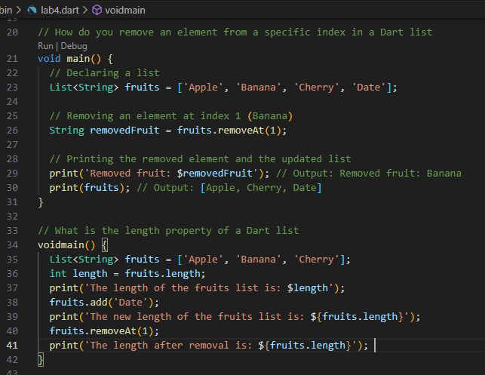

Question 2: Part (1-5)

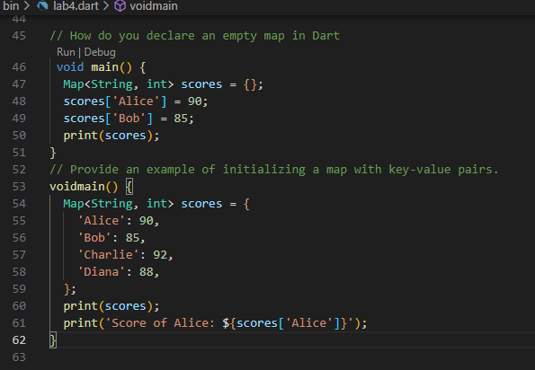

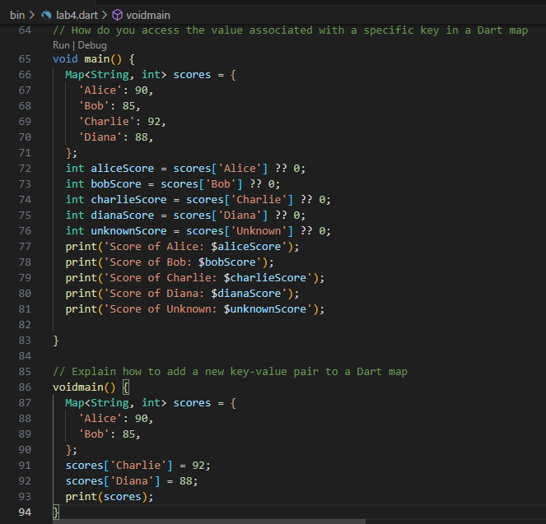

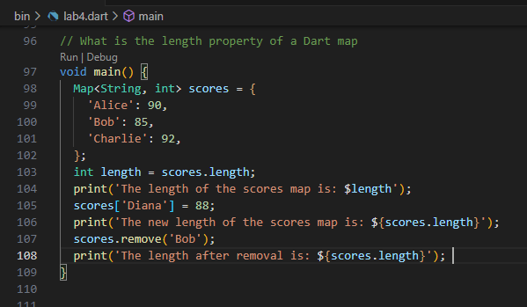

Question 3:

Declare two variables, a and b, with values 15 and 7 respectively. Print their sum

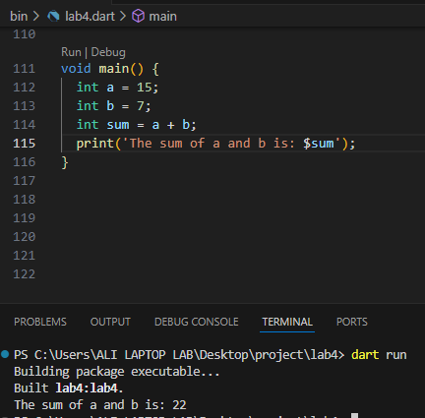

Declare two variables, x and y, with values 10.5 and 3.2 respectively. Print their product.

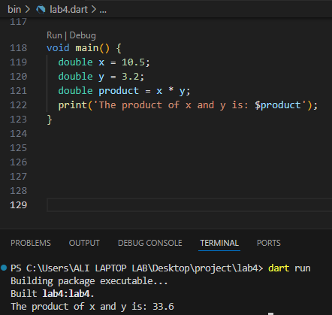

Declare a variable num with a value of -8. Print its absolute value.

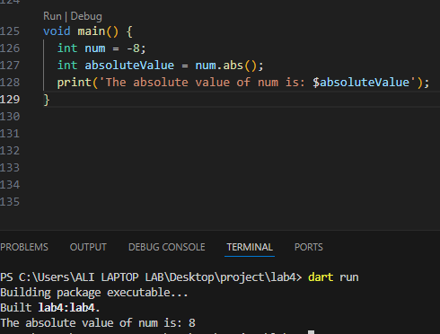

Declare a variable decimal Num with a value of 7.3. Print its ceiling and floor values

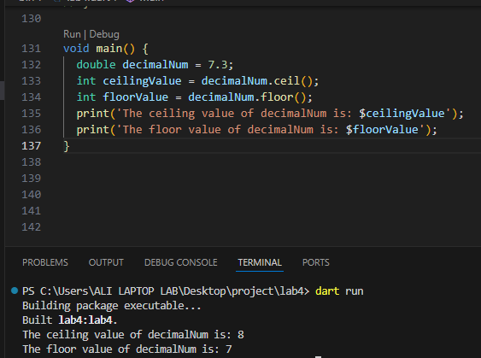

Compare the values of a and b. Print whether a is greater than b.

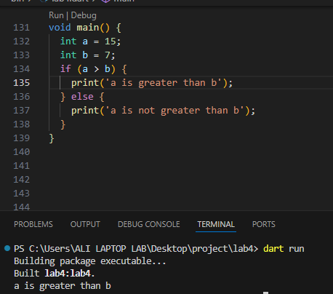

Question 4:

Declare an empty set named mySet in Dart.

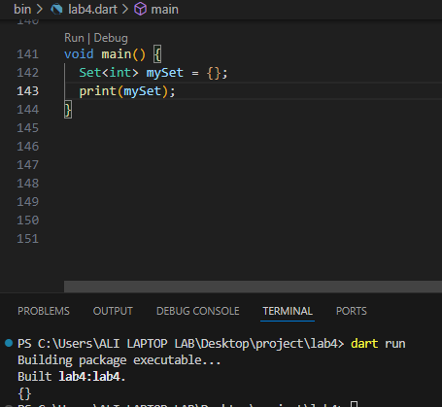

Question 5: Add the numbers 10, 20, and 30 to the set

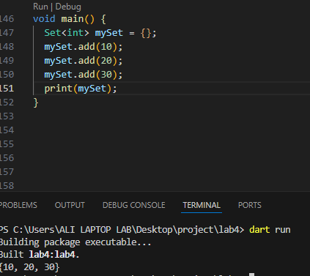

Question 6: Remove the number 20 from the set.

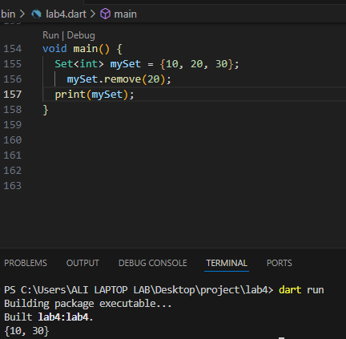

Question 7: Check if the set contains the number 15.

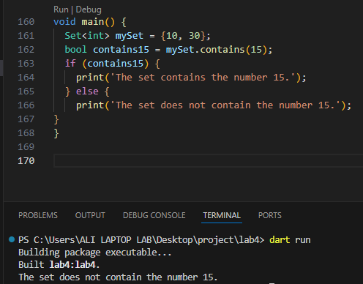

Question 8: Create another set named other Set with numbers 20, 30, and 40.

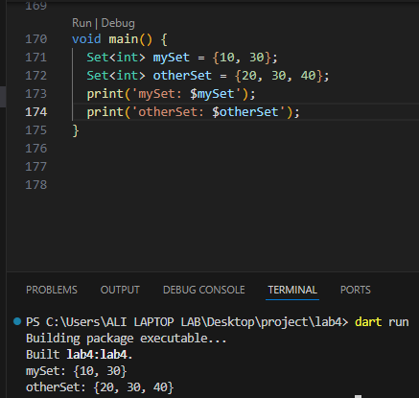

Question 9: Find the union of mySet and otherSet.

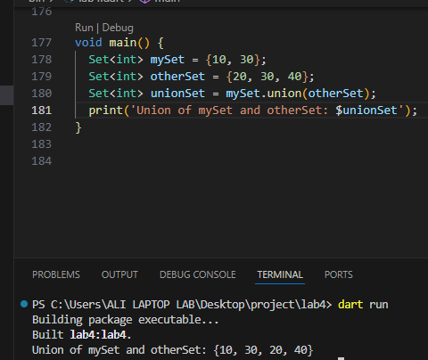

Question 10: Find the intersection of mySet and otherSet.

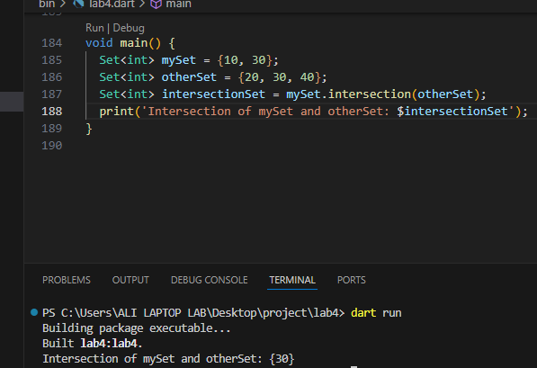

Question 11: Find the difference between mySet and otherSet.

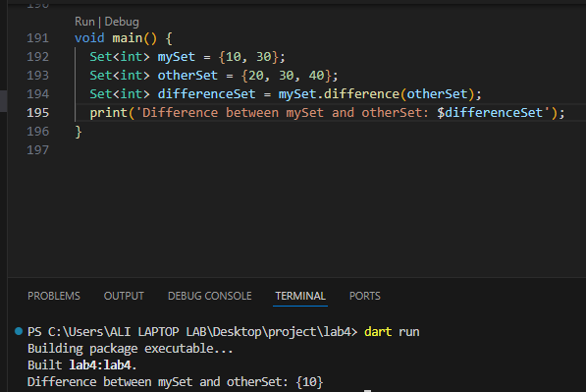

Question 12: Consider a set of unique employee names in a company. Create a Dart program that performs the following tasks:

a. Initialize a set named employee Set with at least three unique employee names.

b. Convert the set to a list named employee List.

c. Convert the set to a map named employee Map where the employee names are used as keys, and their corresponding employee IDs (IDs can be arbitrary) are used as values.

d. Print the original set, the converted list, and the converted map.

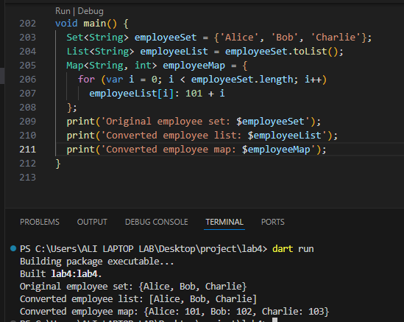

Question 13: 1) Given the map: var student Grades = {'Alice': 90, 'Bob': 85, 'Charlie': 95}; Perform the following operations:

a) Add a new student 'David' with a grade of 88.

b) Update Bob's grade to 90.

c) Remove the student 'Charlie' from the map.

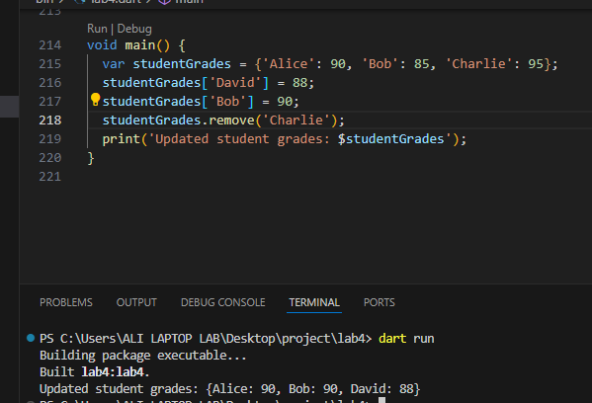

Question 14: Iterate through the map created in question 1 and print each key-value pair

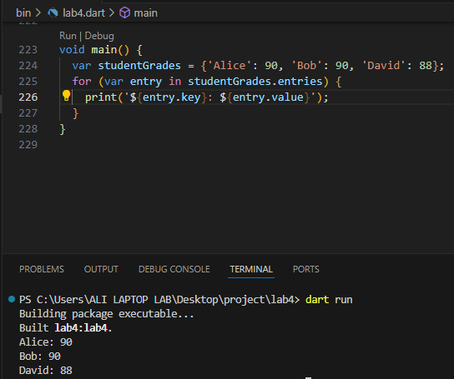

Question 15: Create a map literal with keys as integers and values as strings. Add three key-value pairs of your choice

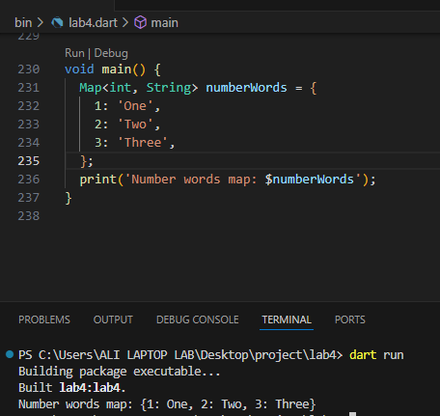

Question 16: Compare two map literals for equality. The first map contains: 'a' -> 1, 'b' -> 2. The second map contains the same key-value pairs but in a different order.

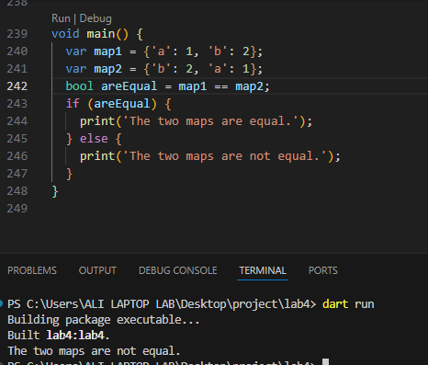

Question 17: Initialize an empty map literal and add the following key-value pairs:

a) name' -> 'John' b) 'age' -> 25 c) 'city' -> 'New York'

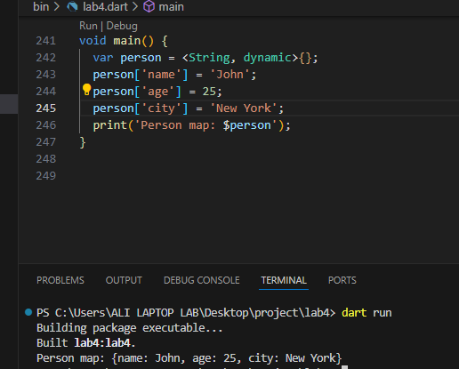

Question 18: 8) Create an unmodifiable map using the unmodifiable constructor with the following key-value pairs: a) 'January' -> 1 b) 'February' -> 2 c) 'March' ->3

